***Python,PIP, Jupiter,Pycharm installation***

Step 1: install python 3 & 2 (***both***) , install it…

Link: <https://www.python.org/downloads/>

Or GoogleDrive:

Step 2: set environment variable:

Link: <https://geek-university.com/python/add-python-to-the-windows-path/>

Check whether your python & PIP are installed correctly or not… by

Open CMD… type..

Python -V

Pip –V

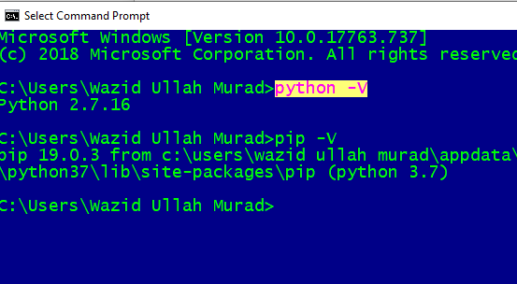

Step 3: install pycharm soft from (download community)

Link: <https://www.jetbrains.com/pycharm/download/#section=windows>

Or. Google Drive:

Step 4: Now install jupyter

Open CMD & write…

pip install jupyter

(it will install jupyter notebook)

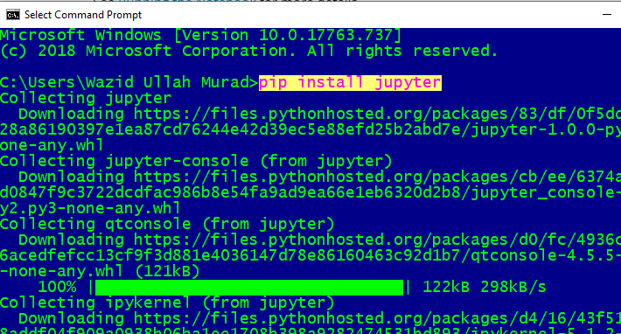

Step 5: how to use Jupiter:

-Open cmd & go to the folder where u want to save the codes..

Command: **jupyter notebook**

It will open a browser with Jupiter notebook..

Write code & run..

Note: if u get fared, please watch bangla tutorial first…

-python install: <https://youtu.be/QJtuhoOfGp0?list=PLlBKlxyCgmsCYJLq9qc5QzaU-oBFJN79B>

-PIP & Jupiter: <https://youtu.be/5RgW0vst5pM>

If more help needed… have a screenshare(LIVE) on Google hangout… call: wazidullahmurad@gmail.com